**Exp No:**

**Digital Thermometer using Keil Software**

**Date:**

**AIM:**

To write an assembly language program for Digital Thermometer using 8051 using Keil and Proteus.

**SOFTWARE REQUIRED:**

* Proteus 8 software.
* Keil software

**CIRCUIT DIAGRAM:**

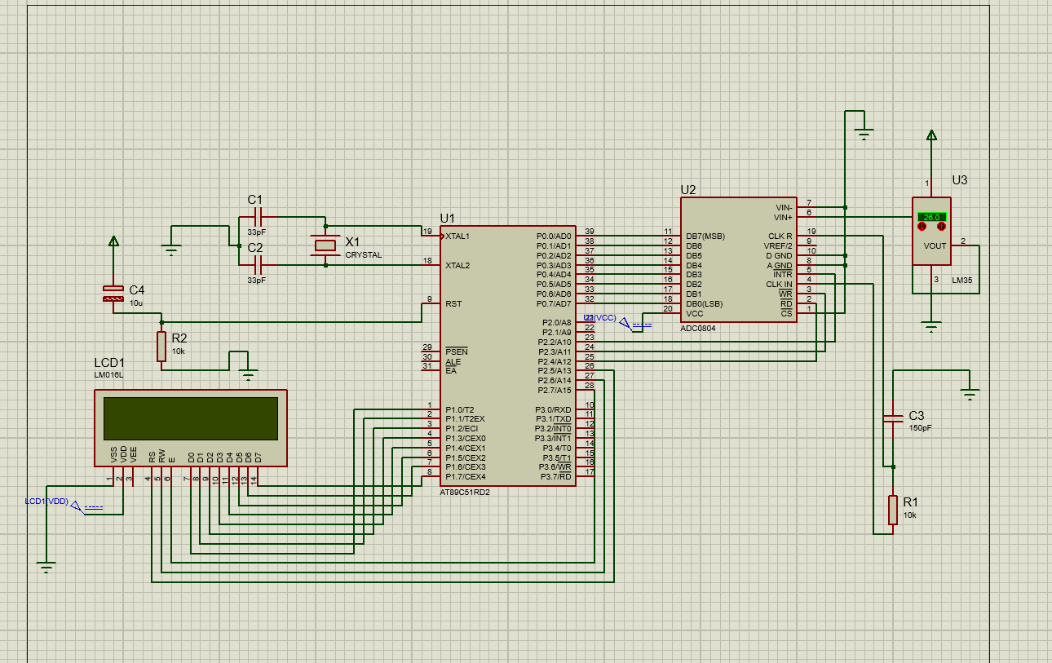

**PROGRAM:**

#include<reg51.h>

#include<string.h>

#define lcd P1

#define input P0

sbit rd=P2^4;

sbit wr=P2^3;

sbit intr=P2^2;

sbit rs=P2^5;

sbit rw=P2^6;

sbit e=P2^7;

void delay (unsigned int);

void cmd (unsigned char);

void ldata (unsigned char);

unsigned int adc();

void string (char *c);

void delay (unsigned int d)

{

unsigned int i;

for(;d>0;d--)

{

for(i=250;i>0;i--);

}

}

void cmd (unsigned char c)

{

lcd=c;

rs=0;

rw=0;

e=1;

delay(5);

e=0;

}

void ldata (unsigned char c)

{

lcd=c;

rs=1;

rw=0;

e=1;

delay(5);

e=0;

}

unsigned int adc() // Reading values from ADC and display on the LED's

{

unsigned int adc=0x00;

rd=1;

wr=0;

delay(10);

wr=1;

while(intr==1);

rd=0;

intr=1;

delay(10);

adc=input;

return(adc);

}

void string (char *c)

{

while(*c)

{

ldata(*c++);

}

}

void main()

{

int i=0,j =0;

unsigned char x3;

unsigned char tmpAdcData;

cmd(0x38);

cmd(0x0c);

cmd(0x01);

cmd(0x80);

while(1)

{

delay(10);

cmd(0x80);

input=0xff;

string("temp:");

cmd(0x85);

tmpAdcData=adc();

ldata((tmpAdcData/1000)+(0x30)); // SEPERATE BITS AND PRINT

tmpAdcData = tmpAdcData%1000;

ldata((tmpAdcData/100)+(0x30));

tmpAdcData = tmpAdcData%100;

ldata((tmpAdcData/10)+(0x30));

tmpAdcData = tmpAdcData%10;

ldata((tmpAdcData)+(0x30));

x3=0xDF;

ldata(x3);

string("c");

}

}